Deploy a full stack python backend and Java CSS frontend application and DB RDS MySql

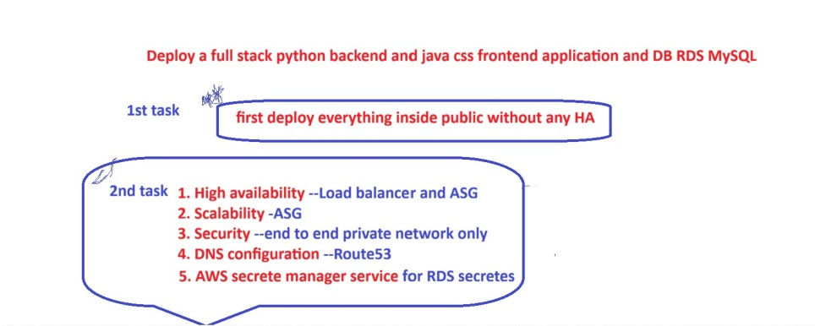

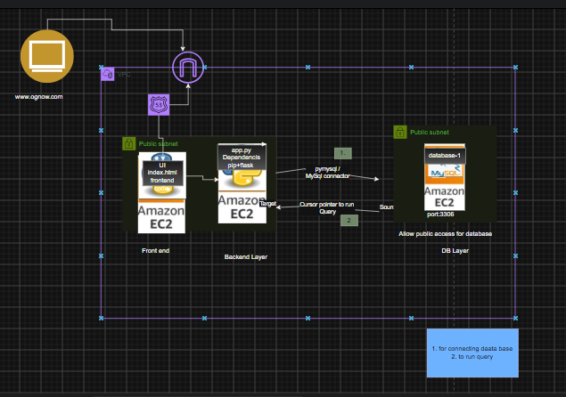

Task -1 Deploy a Full stack app in a public network without HA

Prerequisite:
- One RDS database server with public access and enable AWS managed secrete keys (credentials will be handled by Secrete manager to rotate key automatically) .
- Two public/Bastion server i.e 1 frontend server,1 backend Server.
- Configure Backend server and connect to RDS DB using python backend .(use Mysql workbench or Curl method or postman methods to test connections).start the service
- Configure Frontend server with nginx service ( include frontend code in index.html) and start the service
- Now configure route 53 DNS for the frontend public server ip.and communitcate database using frontend UI .

You can find required repo to execute the task in - DevOps-With-Multicloud-/AWS/26-8-3 Python and node deployment with RDS/python-backend-testing at main · itmukesh-16/DevOps-With-Multicloud-

Steps:-

- One RDS database server with public access and enable AWS managed secrete keys (credentials will be handled by Session manager to rotate key automatically) .

- Create a RDS DB called database-1 and enable AWS Secrete Manager

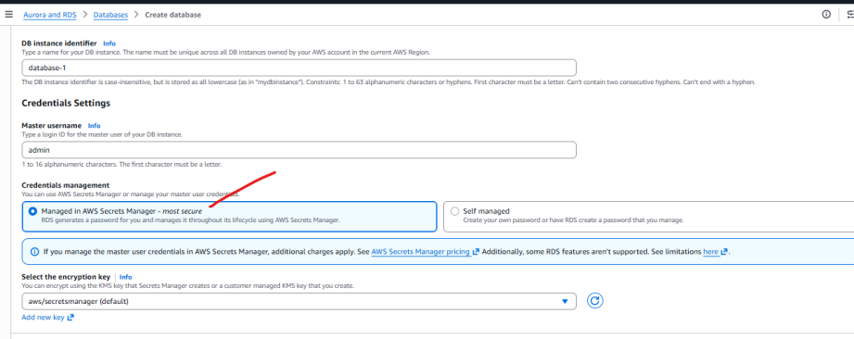

The password will be managed by AWS Session manager.
- Host it is in public subnet but allow public access.
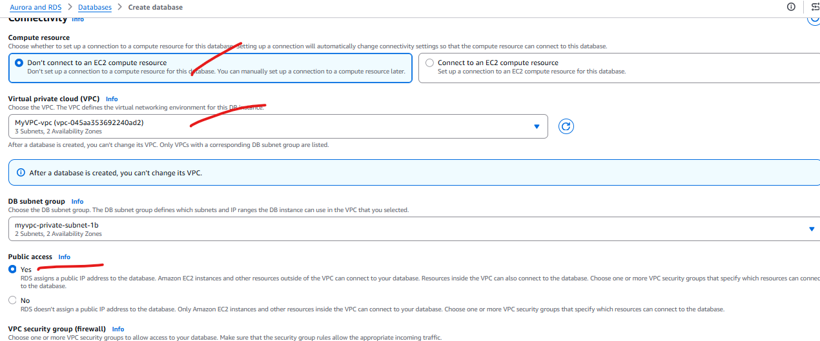

- While selecting SG make sure it follows (ipv4 + allow traffic-anywhere) all as of now. Then create database
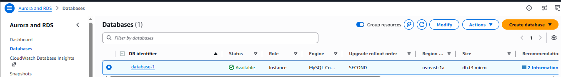

- Using mysql workbench check connection to RDS DB
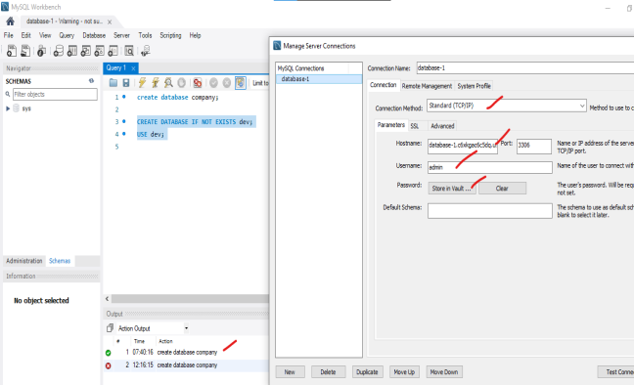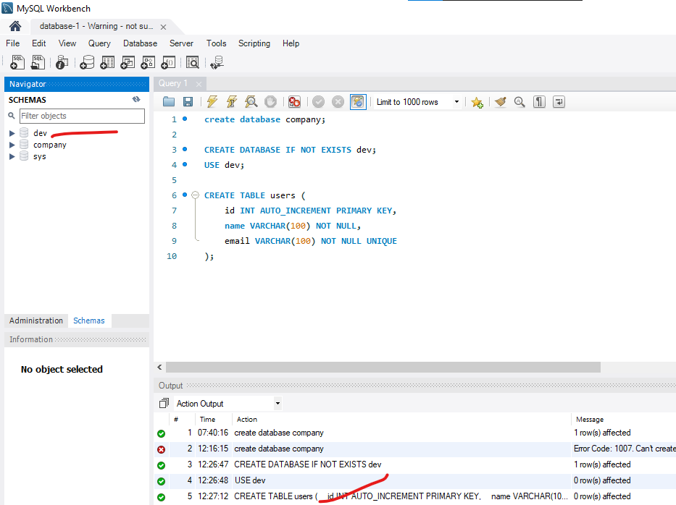

- Two public/Bastion server i.e 1 frontend server,1 backend Server.

- Create a public backend server and allow all the traffics .
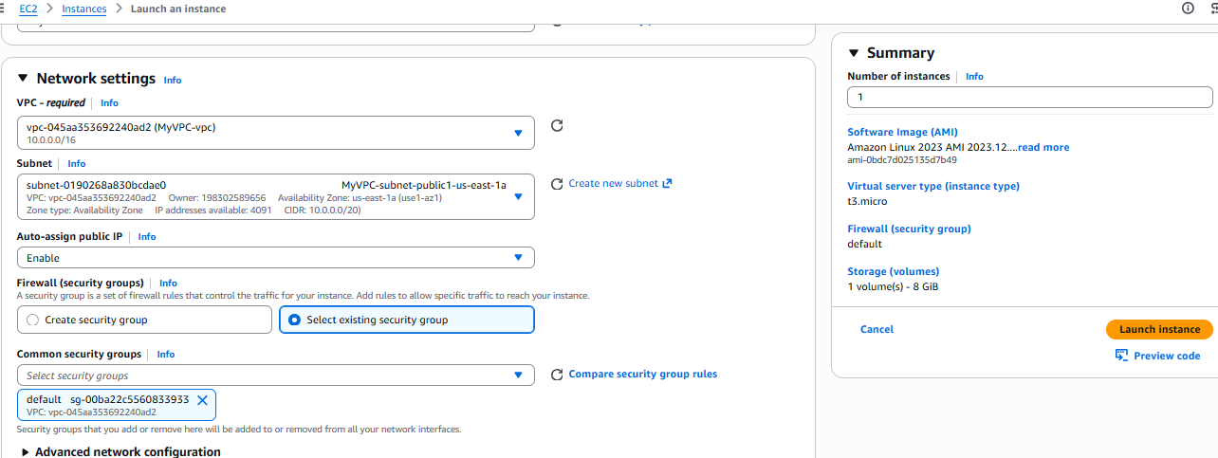

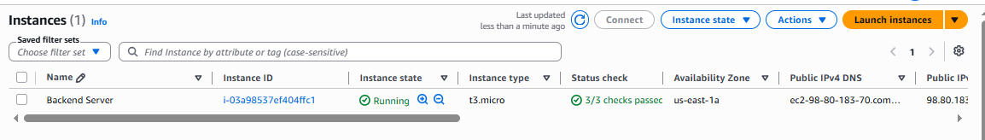

- Configure backend server and connect database.(python +pip+app.py +requirement.txt)
Switch to root user and install [python +pip]
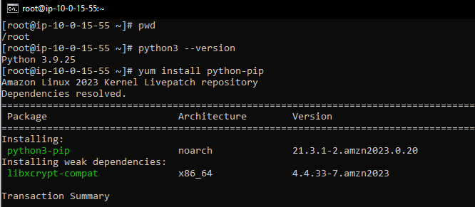
Now create a directory –> backend-call-secrets-secretmanager
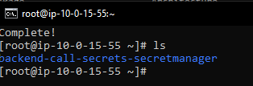

Inside backend-call-secrets-secretmanager > create app.py
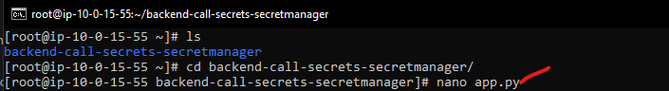
Now create requirement.txt and include dependencies that you want to install .
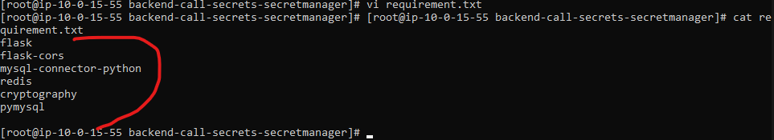
Then install the packages included inside requirement.txt -> pip install –r requirement.txt
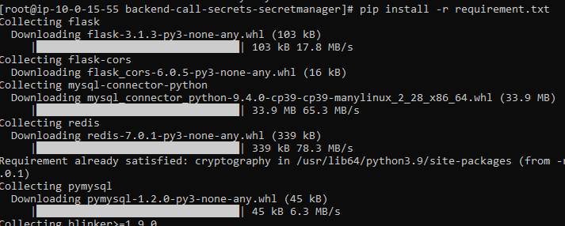
Now include below lines of code to in app.py
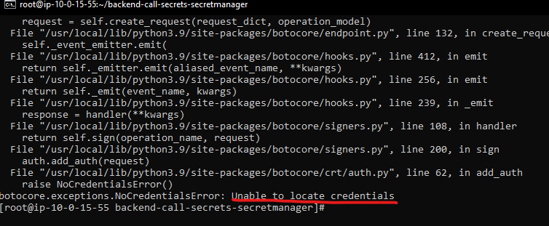
The error means ec2 is not able to access the credentials . now Attach a IAM role with permission - SecretsManagerReadWrite . and attach the role to backend server .

